PROGRAM:

#include <stdio.h>

#include <stdlib.h>

#define MAX_SIZE 100

// Stack implementation int stack[MAX_SIZE]; int top = -1;
void push(int item) {
EXPERIMENT NO 3

if (top >= MAX_SIZE - 1) {

printf("Stack Overflow\n");

return;

}

top++;

stack[top] = item;

}

int pop() {

if (top < 0) {

printf("Stack Underflow\n");

return -1;

}

int item = stack[top];

top--;

return item;

}

int is_operator(char symbol) {

if (symbol == '+' || symbol == '-' || symbol == '*' || symbol == '/') {
return 1;

}

return 0;

}

int evaluate(char* expression) {

int i = 0;

char symbol = expression[i]; int operand1, operand2, result; while (symbol != '\0') {
if (symbol >= '0' && symbol <= '9') {

int num = symbol - '0';

push(num);

}

else if (is_operator(symbol)) {

operand2 = pop(); operand1 = pop(); switch(symbol) {
case '+': result = operand1 + operand2; break; case '-': result = operand1 - operand2; break; case '*': result = operand1 * operand2; break;
case '/': result = operand1 / operand2; break;

}

i++;

}
}

push(result);

symbol = expression[i];
result = pop();

return result;

}

int main() {

char expression[50]; printf("Enter the expression : "); fgets(expression,sizeof(expression),stdin); int result = evaluate(expression);
printf("Result= %d\n", result);

return 0;

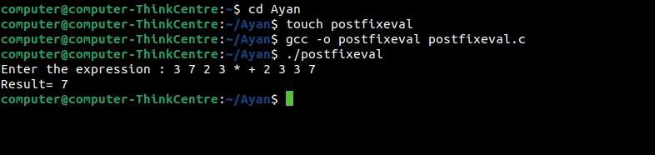} OUTPUT:

